

UMM-E-HABIBA IMRAN

01-134241-048

ZAINAB IDREES

01-134241-051

# Digital Logic Design Lab

LED Roulette Circuit

**Bachelor of Science in Computer Science**

Lab Instructor: Abdul Salam

Department of Computer Science

Bahria University, Islamabad

December 2024

**Abstract**

This project presents the design and implementation of an LED roulette circuit that utilizes the 555 timer IC and the 4017 Decade Counter IC to create a dynamic and visually engaging display. The 555 timer is used to generate the clock pulses, which are fed into the 4017 IC, a decade counter that controls a sequence of 10 LEDs arranged in a circular layout. The LEDs light up in a randomized pattern, simulating the motion of a roulette wheel. The project aims to demonstrate the principles of timing circuits, sequential logic, and light display control. The design prioritizes low-cost components and simplicity in assembly, making it suitable for educational purposes and hands-on learning experiences in electronics. Additionally, the project highlights the practical application of the 555 timer and 4017 IC in controlling multiple outputs and achieving randomization effects, commonly used in games, simulations, and decorative lighting.

i

**Table of Contents**

**Abstract…………………………………………………………………………………………… i**

1. **Introduction …………………………………………………………………………………. 1**
   1. Background Information…………………………………………………………………...1
   2. Project Overview…………………………………………………………………………...1
   3. Objective…………………………………………………………………………………...1
   4. Importance of Project.……………………………………………………………………...2
   5. Scope…………………………………………………………………………………….…2
2. **Theory…………………………………………………………………………………………3**
3. **Components and Software……………………………………………………………………4**
   1. Materials Required.……………………………………………………...…………………4
   2. Software Used……………………………………………………………………………...4
4. **Procedure.………………………….………………………………………………………….5**
   1. When both contacts are touched……………………………………………………………5
   2. Effect on 100nF Capacitor………………………………………………………………….5
   3. Impact on 4017 IC and LED Rotation……………………………………………….……..6
   4. When Touch contacts are removed…………………………………………………………6
5. **Results…………………………………………………………………………………………7**
6. **Discussion……………………………………………………………………………………...8**
   1. Interpretation of Results……………………………………………………………………9
   2. Success of Design……………………………………………………..……………………9
   3. Challenges Faced…………………………...………………………………………………9
   4. Potential Improvements……………………...……………………………………………10
7. **Conclusion……………………………………………………………………………………11**

**References…………………………………………………………………………………………12**

ii

**List of Figures**

Figure 1: LED Roulette Circuit .7 -

Figure 2: Proteus Diagram.............................................................................................................................................7 -

Figure 3: Implemented Circuit.......................................................................................................................................8 -

Figure 4: Main Back Side ............................................................................................................................................. 8 -

Figure 5: Main Working of Circuit............................................................................................................................. 8 -

iii

**List of Tables**

No tables were used in the entire report.

iv

**Acronyms and Abbreviations**

|  |  |
| --- | --- |
| IC | Integrated Circuit |
| LED | Light Emitting Diode |
| PNP | Positive-Negative-Positive |
| RC Network | Resistor-Capacitor Network |
| MΩ | Mega Ohm |
| V | Volt |
| RGB | Red-Blue-Green |
| nF | Nano Farad |

v

**Chapter 1**

**Introduction**

* 1. **Background Information:**

Digital logic design forms the backbone of modern electronics, enabling the creation of circuits that perform complex tasks based on logical operations. By using components like timers, counters, and logic gates, engineers design systems that interpret and process binary signals. Digital logic plays a critical role in areas such as computer hardware, signal processing, and embedded systems. Concepts like clock pulses, sequential circuits, and state machines are central to understanding how digital devices function. Projects like LED-based circuits provide practical applications of these theories, allowing students and hobbyists to experiment with core principles of electronics.

* 1. **Project Overview:**

The LED Roulette Circuit is a hands-on project aimed at implementing a sequential LED flasher using a 555 timer and a 4017-decoder counter IC. This circuit mimics the spinning effect of a roulette wheel by lighting LEDs in a sequential pattern, which eventually slows down and stops. The project demonstrates how clock pulses generated by the 555 timer drive the 4017 IC to activate the LEDs in a predictable sequence. It also shows how resistors and capacitors influence timing, giving users an opportunity to modify the circuit's behavior.

* 1. **Objective:**

The primary objective of the project is to design and implement a functional LED roulette circuit. It aims to:

* + 1. Demonstrate the practical application of a 555 timer and 4017 IC.
    2. Explore the interaction between clock generation, counting, and output sequencing in digital circuits.
    3. Provide insights into how analog and digital components combine to create visually engaging effects.
  1. **Importance of the Project:**

This experiment is significant for understanding the foundational concepts of digital logic, such as clock generation, pulse control, and sequential circuit design. It bridges theoretical knowledge and practical application, making it easier to grasp the real-world functionality of ICs. The project also enhances skills in troubleshooting, circuit optimization, and the implementation of timing-based systems, which are vital in advanced digital electronics.

* 1. **Scope:**

The lab project covers:

* + 1. Design of Logic Circuits: Using the 555 timer IC in astable mode to generate clock signals and the 4017 IC to implement sequential logic.
    2. Implementation of Boolean Expressions: While this project doesn’t directly implement complex Boolean logic, it demonstrates sequential behavior driven by clock pulses and counters.
    3. Timing and Control: Understanding how resistor-capacitor networks affect the clock frequency and the resulting LED sequence speed.
    4. Hands-On Application: Building, testing, and modifying the circuit on a breadboard for real-time experimentation.

**Chapter 2**

**Theory**

The **LED Roulette Circuit** project does not include the following theoretical details:

* + - * **Basic Digital Logic Concepts**: There is no use of logic gates (AND, OR, NOT), Boolean algebra, or truth tables.
      * **Boolean Algebra**: The project does not explain Boolean laws or any techniques for simplifying logical expressions.
      * **Types of Circuits**: While the project utilizes a sequential circuit (the 4017-decoder counter), it does not explicitly classify or discuss the types of circuits (combinational, sequential, flip-flops).
      * **Design Methodologies**: The project does not mention Karnaugh maps, Boolean expressions, or systematic approaches to designing logic circuits.

The **LED Roulette Circuit** focuses on practical implementation using a **555 Timer IC** in astable mode and a **4017 Decade Counter IC** for sequentially lighting LEDs. It does not delve into the theoretical aspects of digital logic design.

**Chapter 3**

**Components and Software**

* 1. **Materials Required**
     1. 555 Timer IC
     2. 4017 IC
     3. PNP Transistor (I used BC557
     4. 10 LED’s
     5. Resistor 100kohm
     6. Resistor 10Mohm
     7. Capacitors: 1uF
     8. Capacitor 100nF
     9. Breadboard And Connectors
     10. Touch Contacts
     11. (5-12) V Power Supply
  2. **Software used:**

**Proteus**: For circuit design and simulation.

**Chapter 4**

**Procedure**

* 1. **When both touch contacts are touched:**
     1. The 1µF capacitor charges due to current flowing through the finger.
     2. As the capacitor charges, the voltage at its positive terminal approaches the positive rail voltage, while the voltage at its negative terminal moves closer to the negative rail.
     3. The negative terminal of the capacitor is connected to the base of a PNP transistor via a 10MΩ resistor.
     4. As the negative terminal voltage rises, the base of the PNP transistor becomes more negative, biasing it to conduct current between its emitter and collector.
     5. The greater the negative voltage at the base, the higher the conductivity between the emitter and collector of the transistor.
  2. **Effect on the 100nF Capacitor (near 555 Timer IC):**
     1. One terminal of the 100nF capacitor is connected to the negative rail, while the other terminal connects to the positive rail through a 10kΩ resistor and the transistor.
     2. As the transistor conducts more, the 100nF capacitor charges more quickly, which in turn increases the frequency of the square wave output from the 555 timer IC.
  3. **Impact on the 4017 IC and LED Rotation:**
     1. The output of the 555 timer IC is connected to the clock input of the 4017 IC.
     2. Since the clock input of the 4017 IC is driven by the frequency of the output from the 555 timers, an increase in frequency causes the LEDs to rotate faster.
  4. **When the touch contacts are removed:**
     1. The 1µF capacitor discharges slowly. As the capacitor discharges, the conductivity of the PNP transistor decreases, reducing the rate at which the 100nF capacitor charges.
     2. As a result, the frequency of the output wave from the 555 timer IC decreases, causing the speed of the LED rotation to slow down.
     3. The output of the LED Roulette Circuit will be a **sequential lighting pattern** of LEDs, simulating the rotation of a roulette wheel.

**Chapter 5**

**Results**

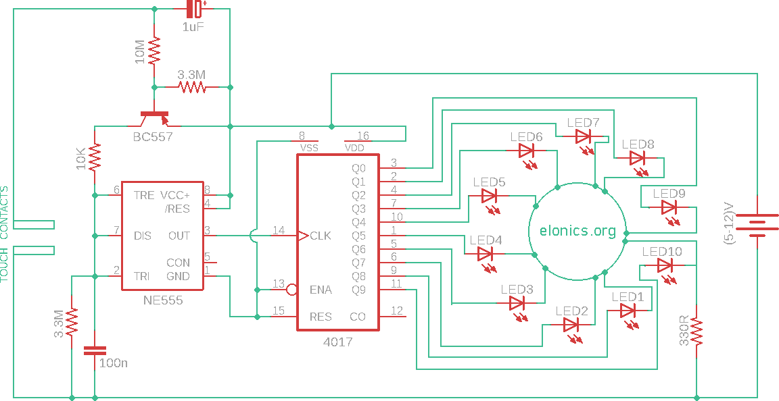

*Figure 1: LED Roulette Circuit*

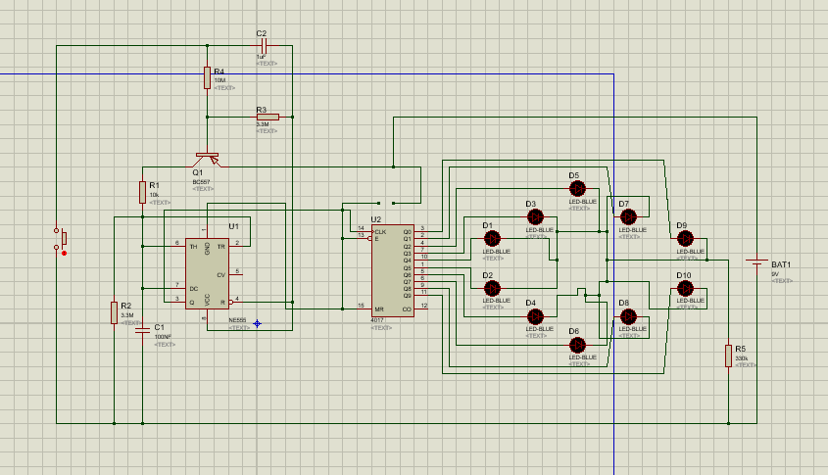

*Figure 2: Proteus Diagram*

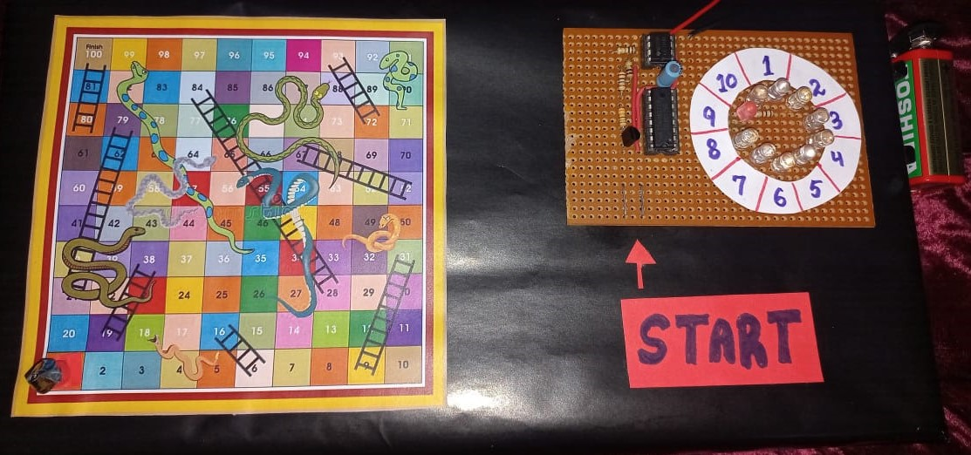

*Figure 3: Implemented Circuit*

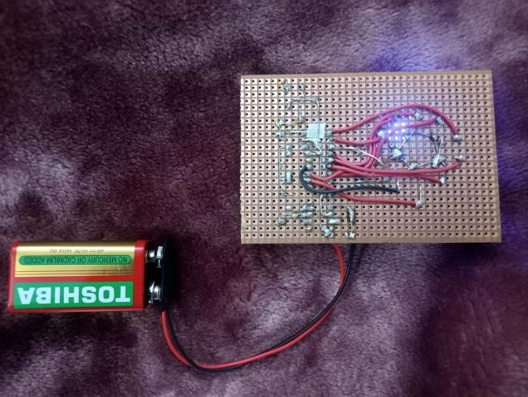

*Figure 4: Main Back Side*

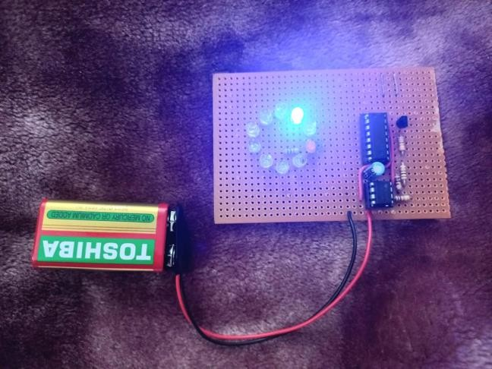

*Figure 5: Main Working of Circuit*

**Chapter 6**

**Discussion**

* 1. **Interpretation of Results:**

The expected behavior of the circuit is for the LEDs to light up sequentially, mimicking a roulette wheel. This effect is driven by the clock pulses generated by the 555 Timer IC and processed by the 4017 Decade Counter IC. If implemented correctly, the observed results should align with theoretical predictions:

* + 1. The timer generates clock signals at a frequency determined by the RC network.
    2. The decade counter switches between its output pins in sync with the clock pulses, lighting the LEDs sequentially.
  1. **Success of Design:**

The circuit is described as functional, successfully achieving the roulette effect with sequentially flashing LEDs that slow down over time. This indicates that the design works as intended. However, the project does not explicitly discuss whether there were deviations or challenges faced during testing.

* 1. **Challenges Faced:**

Common issues in the project include:

* + 1. Faulty Components: A malfunctioning IC, loose connections, or improper resistor/capacitor value could disrupt the circuit.
    2. Timing Issues: Incorrect values for resistors or capacitors in the 555 Timer's RC network could result in unexpected clock frequencies, affecting the LED sequence.
    3. Power Supply Problems: Inconsistent voltage could lead to erratic behavior of LEDs or ICs.

These challenges are often addressed through troubleshooting, component testing, and rechecking connections.

* 1. **Potential Improvements:**
     1. Adjustable Timing: Incorporating a potentiometer in the RC network of the 555 Timer IC could allow users to adjust the speed of the LED sequence.
     2. Enhanced Visuals: Adding more LEDs or integrating RGB LEDs could make the circuit more visually appealing.
     3. Microcontroller Integration: Replacing the 4017 IC with a microcontroller like Arduino could offer greater flexibility, enabling custom patterns or effects.
     4. Power Efficiency: Optimizing resistor and capacitor values to minimize power consumption.

**Chapter 7**

**Conclusion**

The project successfully demonstrates the practical application of a 555 Timer IC and a 4017 Decade Counter IC to create a sequential LED display that mimics a roulette effect. The key outcomes include an understanding of the 555 Timer's role in generating clock pulses, observing how the 4017 IC processes these pulses to sequentially light up LEDs, and achieving a simple yet visually appealing circuit that introduces users to sequential logic and timer-based circuits. Lessons learned throughout the project include gaining a deeper understanding of component interaction, particularly how ICs like the 555 Timer and 4017 work together to produce the desired outputs. Building the circuit enhanced practical skills in handling electronic components and interpreting schematic diagrams, while troubleshooting skills were developed by identifying and addressing issues such as incorrect wiring or component malfunctions. For future work, there are several areas for improvement, such as incorporating advanced effects using a microcontroller like Arduino to enable programmable patterns or different LED arrangements. Additionally, exploring ways to reduce power consumption by optimizing resistor and capacitor values or using more efficient LEDs could improve energy efficiency. Lastly, the circuit design could be extended to include educational modules that explain digital logic concepts, making it a valuable learning tool.

**References**

**[1] Website Article:**

Eronics. (n.d.). *LED Roulette Circuit Using 555 Timer & 4017 IC*. Retrieved June 16, 2024, from <https://elonics.org/led-roulette-circuit-using-555-timer-4017-ic/>